山西忻州市2017年小学毕业考试
英语试题（卷）（PEP A）
（本试卷共6页，满分100分）
题号 | 听力部分 |  |  | 笔试部分 |  |  |  |  |  |  | 总分
 | 一 | 二 | 三 | 一 | 二 | 三 | 四 | 五 | 六 | 七
得分

听力部分（30分）
得分 | 评卷人

- 听录音，排序号。（10分）

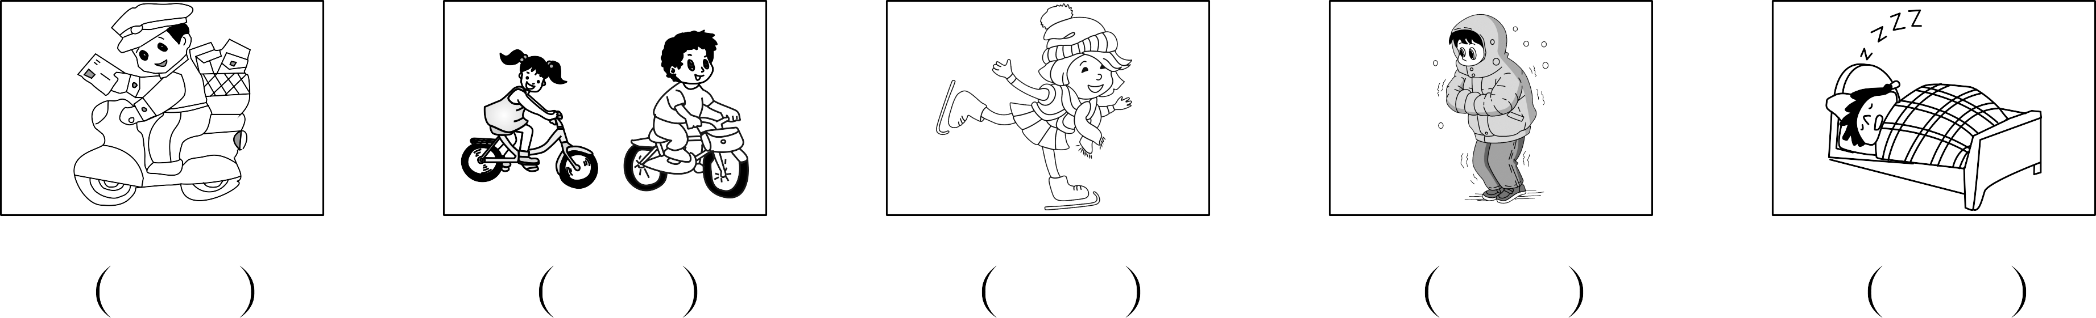

得分 | 评卷人
二、听录音，选出合适的应答语。（10分）

( )l.A.Yes,it is mine. B.Yes,I am. C.Yes,I do.
( )2.A.It is fun. B.It was fun. C.It will be fun.
( )3.A.I like it. B.No,I don’t. C.No, I didn’t.
( )4.A.I go to the park. B.I go there on Sunday. C.I went to the park.
( )5.A.He’s a policeman. B.She is a teacher. C.She is tall.

得分 | 评卷人

三、听录音，填空完成短文。（10分）

Wu Yifan a race with his father and Max.There many people there. His father very fast,but Wu Yifan could not.There was nothing he do.He so worried.“I could run fast at school,”he thought.“Why am I so slow now?”
笔试部分（70分）
得分 | 评卷人

一、选出不同类的单词。（10分）

( )l.A.stay B.slept C.wash
( )2.A.eat B.fish C.egg
( )3.A.gym B.hall C.grass
( )4.A.gift B.robot C.ball
( )5.A.stronger B.big C.taller
得分 | 评卷人

二、单项选择。（10分）

( )l.The man is cleaner.
A.a B.an C./
( )2.She likes a book in the morning.
A.read B.reads C.reading
( )3.I an interesting dream last night.
A.has B.had C.have
( )4.I am different now.I had short hair before,but now I have hair.
A.long B.longer C.short
( )5.I look it up the Internet.
A.in B.at C.on
( )6.I don’t like PE class.I run fast.
A.can B.could C.can’t
( )7.There was no gym .
A.too B.either C.also
( )8.There are dinosaurs.
A.a lot B.a lots C.lots of
( )9.Today is a day.
A.sunny B.Sunday C.sun
( )l0.He is very cute.I like very much.
A.he B.him C.his

得分 | 评卷人
三、看图，根据句意，完成下列句子。（10分）

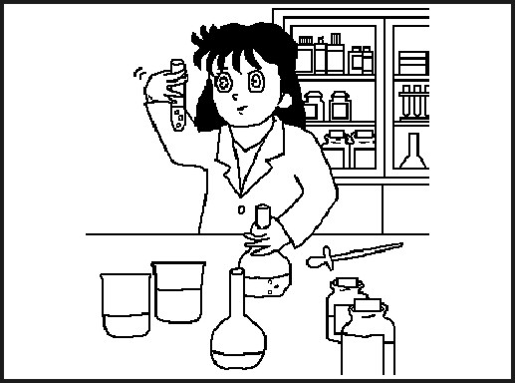
1.Look at the woman,she is a .
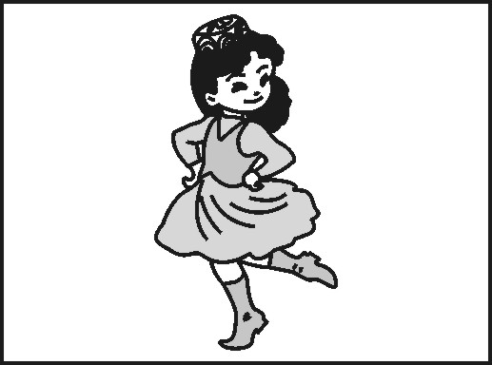
2.My friend likes .
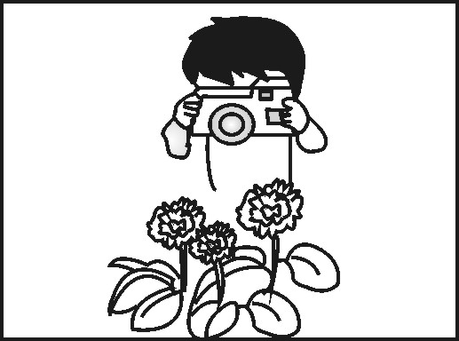
3.He went swimming every weekend and many pictures.
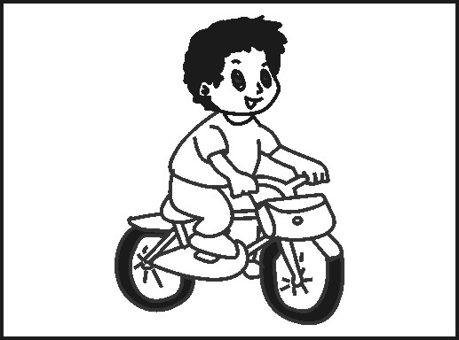
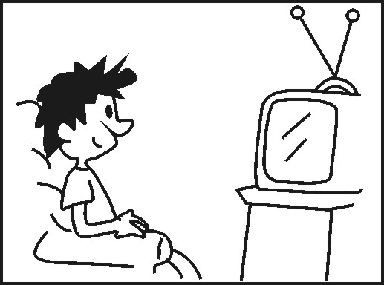
4.I TV every day. .
5.He cycling every Friday.
得分 | 评卷人

四、选择合适的句子完成下列对话。（10分）

Grandpa:Wow, a library! There was no library in my old school.
Sarah:1.
Grandpa:There was only one small building on a hill.
Wu Yifan:2.
Grandpa:Yes,I liked the stars.
Sarah:3. One day I’m going to visit the moon.
Wu Yifan:The Americans took about five days to get there in 1969.
Sarah:4:
Wu Yifan:Easy,I looked it up on the Internet.
Grandpa:Ah!5.
A.Could you see stars at night? B.How do you know that?
C.Tell us about your school, please. D.Me too.
E.There were no computers or Internet in my time.

得分 | 评卷人

五、应答语配对。（10分）

( )l.How old are you? A.Yes,I do.
( )2.What did you do? B.Sure.
( )3.Do you go to Turpan? C.I stayed at home and watched TV.
( )4.Can I come and visit you? D.I am ten.
( )5.What can you see? E.I can see some cows.
得分 | 评卷人

六、阅读短文，判断正(T)误(F)。（10分）
Jack is a doctor.He is my good friend.He was back from London yesterday,and he called me to have supper with him at 7:00 p.m.in my house.But he didn’t know my new address,so I told him and left the key under the door mat(垫子).I worked for a long time yesterday until late in the evening.When I was working,Jack called me again.He said,“I’m in your home.I had some cakes and meat.I’m watching TV now.But I didn’t find the key.”“How did you get into the room?”I asked.“I climbed up a pear tree beside your open window,then came in.”“There isn’t a tree beside my window.In fact,there is a tree near my neighbor’s!”I said.
( )1.Jack is my brother.
( )2.Jack wanted to see a doctor at 7:00 p.m.yesterday.
( )3.Jack had some cakes and meat in my neighbour’s house.
( )4.I didn’t tell Jack my new address and I didn’t leave the key under the door mat.
( )5.There is a tree beside my neighbour’s house.
得分 | 评卷人

七、习作。（10分）
世间万物都在变化，几年前的你和现在的你一定也有了不少的变化，请介绍一下几年前的你和现在的你有什么不同吧！

2017年小学毕业考试
英语听力材料（PEP A）
（每题读两遍）
一、听录音，排序号。
1.I love to ice-skate.
2.Is your father a postman?
3.I slept at home yesterday.
4.I want to ride a bike this weekend.
5.In winter,it is cold.
二、听录音，选出合适的应答语。
1.Is this your book?
2.How was your weekend?
3.Do you like it?
4.Where did you go？
5.What does your mother do?
三、听录音，填空完成短文。
Wu Yifan had a race with his father and Max.There were many people there.His father ran very fast,but Wu Yifan could not.There was nothing he could do.He was so worried.“I could run fast at school,”he thought.“Why am I so slow now?”
2017年小学毕业考试
英语参考答案（PEP A）
听力部分（30分）
一、（10分）2 4 1 5 3
二、（10分）1—5 ABBCB
三、(10分）l.had 2.were 3.ran 4.could 5.was
笔试部分（70分）
一、（10分）1—5 BACAB
二、（10分）1—5 ACBAC 6—10 CBCAB
三、（10分）1.scientist 2.dancing 3.took 4.watch 5.goes
四、（10分）1—5 CADBE
五、（10分）1—5 DCABE
六、（10分）1—5 FFTFT
七、（10分）
I’m 12 years old now and I’m a big boy. Before I was short and thin.But now I am tall and strong. I often do exercise.I can’t ride a bike before.But now I ride a bike with my friends every day. Because we go to school by bike.Before I didn’t do housework.Now I often help my mother do housework on the weekend.I’m very helpful.

